# Project: Analyzing a Market Test

Complete each section. When you are ready, save your file as a PDF document and submit it [here](https://classroom.udacity.com/nanodegrees/nd008/parts/11a7bf4c-2b69-47f3-9aec-108ce847f855/project).

## Step 1: Plan Your Analysis

*To perform the correct analysis, you will need to prepare a data set. (500 word limit)*

*Answer the following questions to help you plan out your analysis:*

1. What is the performance metric you’ll use to evaluate the results of your test?

**We want to apply the menu changes for all stores at least 18% increase in profit growth.**

1. What is the test period?

**The period of 12 weeks (2016-April-29 to 2016-July-21).**

1. At what level (day, week, month, etc.) should the data be aggregated?

**It will be aggregated weekly level.**

## Step 2: Clean Up Your Data

*In this step, you should prepare the data for steps 3 and 4. You should aggregate the transaction data to the appropriate level and filter on the appropriate data ranges. You can assume that there is no missing, incomplete, duplicate, or dirty data. You’re ready to move on to the next step when you have weekly transaction data for all stores.*

## Step 3: Match Treatment and Control Units

*In this step, you should create the trend and seasonality variables, and use them along with you other control variable(s) to match two control units to each treatment unit. Note: Calculate the number of transactions per store per week to calculate trend and seasonality.*

*Apart from trend and seasonality...*

1. What control variables should be considered? Note: Only consider variables in the RoundRoastersStore file.

**AvgMonthSales should be considered and the SQ_FT (square feet) can be ignored.**

1. What is the correlation between your each potential control variable and your performance metric?

**I used Association Analysis tool to test the SQ_FT, AvgMonthSales and Sum_Gross.Margin.**

**The Gross margin has positive correlation of 0.008 with sum Gross margin than the SQ_FT has a negative correlation.**

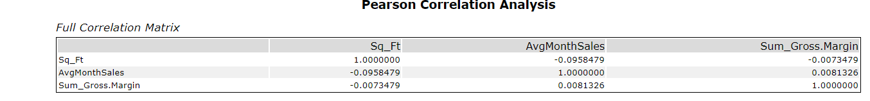

1. What control variables will you use to match treatment and control stores?

**The average sales per month will used with the trend and the seasonality when match treatment and control stores.**

1. Please fill out the table below with your treatment and control stores pairs:

|  |  |  |
| --- | --- | --- |
| Treatment Store | Control Store 1 | Control Store 2 |
| 1664 | 1964 | 8562 |
| 1675 | 1807 | 7584 |
| 1696 | 1863 | 7334 |
| 1700 | 7073 | 1508 |
| 1712 | 8162 | 7434 |
| 2288 | 2568 | 9081 |
| 2293 | 12219 | 9639 |
| 2301 | 11668 | 12019 |
| 2322 | 9238 | 9388 |
| 2241 | 2572 | 3102 |

## Step 4: Analysis and Writeup

*Conduct your A/B analysis and create a short report outlining your results and recommendations. (250 words limit)*

*Answer these questions. Be sure to include visualizations from your analysis:*

1. What is your recommendation - Should the company roll out the updated menu to all stores?

**As per in the report yes, I will be recommended to update the menu to all stores.**

1. What is the lift from the new menu for West and Central regions (include statistical significance)?

* **The Central: Lift = 4.8% and the significance level = 88.5%**



* **The West: Lift = 6.3% and the significance level = 97.3%**



1. What is the lift from the new menu overall?

**The lift from the new menu overall is 6.3% with significance level = 97.3%**

**Clean Data workflow**

**AB Trend workflow**

**AB Analysis workflow**